Develop Email templates for below scenarios: -
- Enrolment of one or more MIGP programs in a single transaction
- Unenrolment of one or more MIGP programs in a single transaction
- Participation changes of one or more MIGP programs in a single transaction (NT_MIGP_PARTICIPATION_CHANGE_ET_V6)
Develop Email templates for below scenarios:
- MIGP_CONTRIBUTION_PAYMENT_INITIATED_ET_V1
- MIGP_CONTRIBUTION_PAYMENT_DECLINED_ET_V1

 |  | Status
1493 | NT_MIGP_PARTICIPATION_CHANGE_ET_V4 | Done
1498 | NT_MIGP_PARTICIPATION_CHANGE_ET_V6 | Done
1453 | NT_MIGP_PROGRAM_WELCOME_ET_V4
1451 | NT_MIGP_PROGRAM_CANCELLATION_ET_V9
1454 | NT_MIGP_PROGRAM_FORCE_CANCELLATI_v4

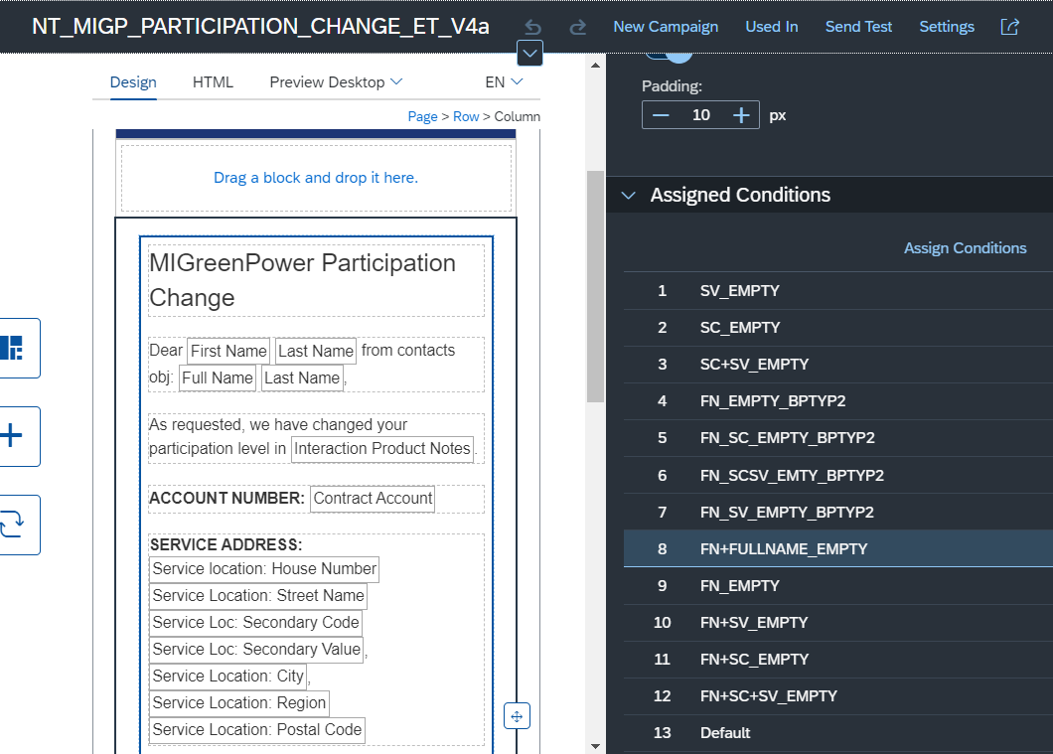

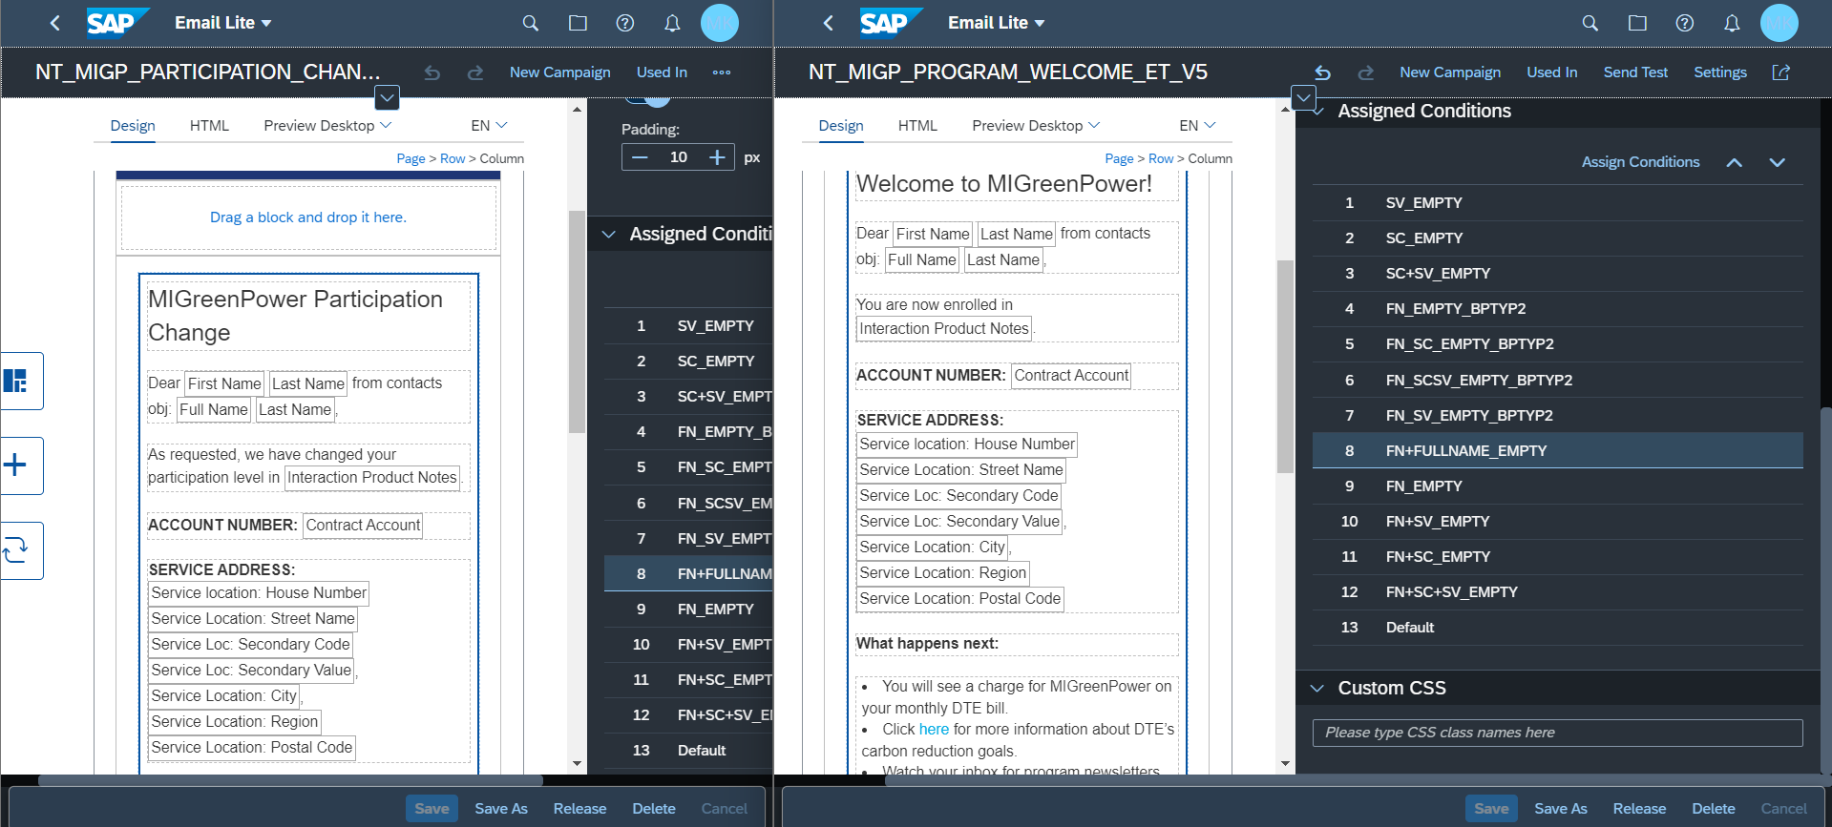

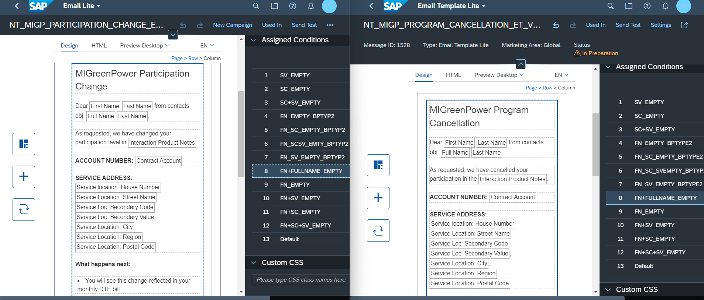

Campaigns

 | Campaign Name | Email Template Used
 | MIGPGREEN Enrollment Confirmation | NT_MIGP_PROGRAM_WELCOME_ET_V5 (1507)
 | MIGPGREEN Participation Confirmation | NT_MIGP_PARTICIPATION_CHANGE_ET_V4 (1493)
 | MIGPGREEN Unenrollment Confirmation | NT_MIGP_PROGRAM_CANCELLATION_ET_V10 (1529)
 | MIGPGREEN Forced Unenrollment Confirm | NT_MIGP_PROGRAM_FORCE_CANCELLATION_V5 (1532)
 | MIGP OneTime Cont - Payment Initiated
 | MIGP OneTime Cont - Payment Declined

